Rockbuster
Data Dictonary
Gabriela Silva Cascione
2026
Table of Contents
LEGEND 2
1.1 ERD 2
2.1 FACTS TABLES 3
2.1.1 payment 3
2.1.2 rental 3
2.2 DIMENSION TABLES 4
2.2.1 actor 4
2.2.2 address 5
2.2.3 category 5
2.2.4 city 6
2.2.5 country 6
2.2.6 customer 7
2.2.7 film 8
2.2.8 film_actor 8
2.2.9 film_category 9
2.2.10 inventory 9
2.2.11 language 10
2.2.12 staff 10
2.2.13 store 11

LEGEND
PK – Primary key
FK – Foreign key
CK – Composite Key

1.1 ERD
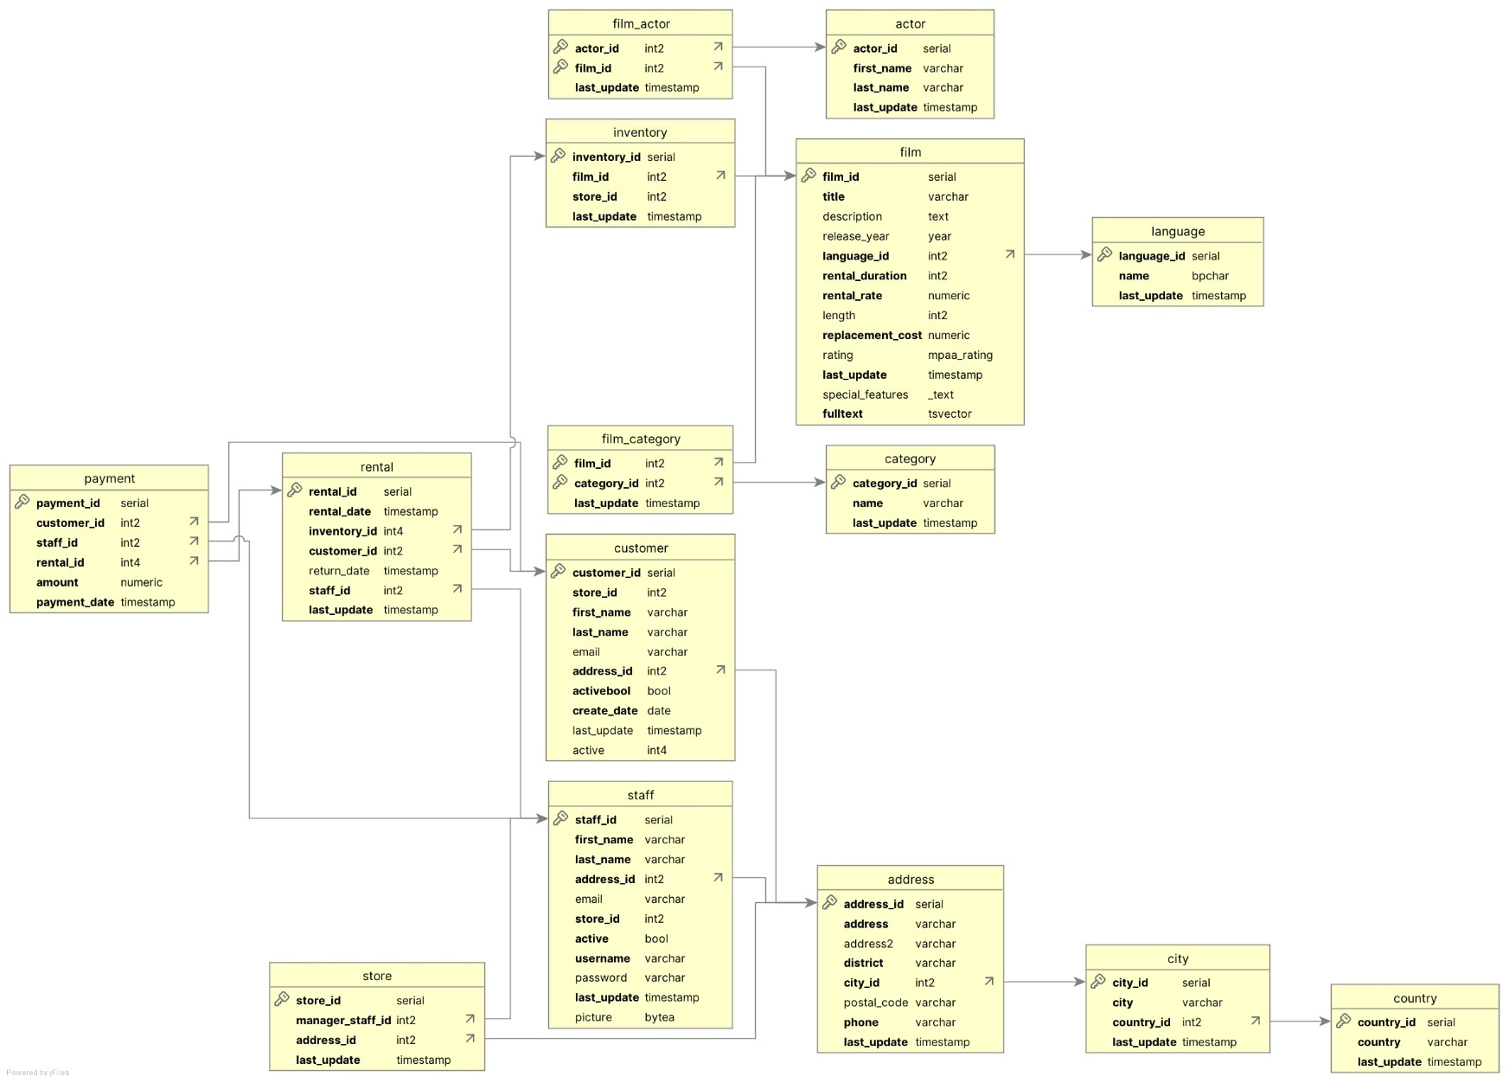

2.1 FACTS TABLES

2.1.1 payment
Column Name | Data Type | Data type name | Description
payment_id | 4 | serial | unique identifier of the payment
customer_id | 5 | int2 | unique identifier of the customer
staff_id | 5 | int2 | unique identifier of the staff that processed the payment
rental_id | 4 | int4 | unique identifier of the rental
amount | 2 | numeric | cost of the rental
payment_date | 93 | timestamp | when the payment was made (date and time)

Links to
Links to table | Join
customer | customer_id = customer_id
staff | staff_id = staff_id
rental | rental_id = rental_id
Unique Keys
Key Type | Column
PK | payment_id
FK | customer_id
FK | staff_id
FK | rental_id

2.1.2 rental
Column Name | Data Type | Data type name | Description
rental_id | 4 | serial | unique identifier of the rental
rental_date | 93 | timestamp | when the rental started (date and time)
inventory_id | 4 | int4 | unique identifier of the inventory
customer_id | 5 | int2 | unique identifier of the customer
return_date | 93 | timestamp | when the rental finished (date and time)
staff_id | 5 | int2 | unique identifier of the staff that processed the rental
last_update | 93 | timestamp | when this record was last updated (date and time)

Links to
Links to table | Join
inventory | inventory_id = inventory_id
customer | customer_id = customer_id
staff | staff_id = staff_id

Links from
Linked from table | Join
payment | rental_id = rental_id
Unique Keys
Key Type | Column
PK | rental_id
FK | inventory_id
FK | customer_id
FK | staff_id

2.2 DIMENSION TABLES

2.2.1 actor
Column Name | Data Type | Data type name | Description
actor_id | 4 | serial | unique identifier of the actor
first_name | 12 | varchar | actor`s first name
last_name | 12 | varchar | actor`s last name
last_update | 93 | timestamp | when this record was last updated (date and time)

Links from
Linked from table | Join
film_actor | actor_id = actor_id
Unique keys
Key Type | Column
PK | actor_id

2.2.2 address
Column Name | Data Type | Data type name | Description
address_id | 4 | serial | unique identifier of the address
address | 12 | varchar | street name and building number
address2 | 12 | varchar | additional address information
district | 12 | varchar | district of the address
city_id | 5 | int2 | unique identifier of the city
postal_code | 12 | varchar | postal code of the address
phone | 12 | varchar | phone number of this address
last_update | 93 | timestamp | when this record was last updated (date and time)

Links to
Links to table | Join
city | city_id = city_id

Links from
Linked from table | Join
staff | address_id = address_id
customer | address_id = address_id
store | address_id = address_id

Unique Keys
Key Type | Column
PK | address_id
FK | city_id

2.2.3 category
Column Name | Data Type | Data type name | Description
category_id | 4 | serial | unique identifier of the category
name | 12 | varchar | name of the category
last_update | 93 | timestamp | when this record was last updated (date and time)

Links from
Linked from table | Join
film_category | category_id = category_id
Unique keys
Key Type | Column
PK | category_id

2.2.4 city
Column Name | Data Type | Data type name | Description
city_id | 4 | serial | unique identifier of the city
city | 12 | varchar | name of the city
country_id | 5 | int2 | unique identifier of the country
last_update | 93 | timestamp | when this record was last updated (date and time)

Links to
Links to table | Join
country | country_id = country_id

Links from
Linked from table | Join
address | city_id = city_id
Unique keys
Key Type | Column
PK | city_id
FK | country_id

2.2.5 country
Column Name | Data Type | Data type name | Description
country_id | 4 | serial | unique identifier of the country
country | 12 | varchar | name of the country
last_update | 93 | timestamp | when this record was last updated (date and time)

Links from
Linked from table | Join
city | country_id = country_id
Unique keys
Key Type | Column
PK | country_id

2.2.6 customer
Column Name | Data Type | Data type name | Description
customer_id | 4 | serial | unique identifier of the customer
store_id | 5 | int2 | unique identifier of the store
first_name | 12 | varchar | customer`s first name
last_name | 12 | varchar | customer`s last name
email | 12 | varchar | customer`s email
address_id | 5 | int2 | unique identifier of the address
activebool | -7 | bool | shows if staff is active or not (true or false)
create_date | 91 | date | when was this line create (date only)
last_update | 93 | timestamp | when this record was last updated (date and time)
active | 4 | int4 | shows if staff is active or not (1 or 0)

Links to
Links to table | Join
store | store_id = store_id
address | address_id = address_id

Links from
Linked from table | Join
rental | customer_id = customer_id
Unique keys
Key Type | Column
PK | customer_id
FK | store_id
FK | address_id

2.2.7 film
Column Name | Data Type | Data type name | Description
film_id | 4 | serial | unique identifier of the film
title | 12 | varchar | name of the movie
description | 12 | text | description of the movie
release_year | 2001 | year | year the movie was released
language_id | 5 | int2 | unique identifier of the language of the movie
rental_duration | 5 | int2 | max rent duration possible (in days)
rental_rate | 2 | numeric | cost of the rental
length | 5 | int2 | how long is the movie in minutes
replacement_cost | 2 | numeric | cost to replace the movie
rating | 12 | mpaa_rating | age rating of the movie
last_update | 93 | timestamp | when this record was last updated (date and time)
special_features | 2003 | _text | extra content (e.g trailers, behind the scenes)
fulltext | 1111 | tsvector | key words for search

Links to
Links to table | Join
language | language_id = language_id

Links from
Linked from table | Join
film_actor | film_id = film_id
Unique keys
Key Type | Column
PK | film_id
FK | language_id

2.2.8 film_actor
Column Name | Data Type | Data type name | Description
actor_id | 5 | int2 | unique identifier of the actor
film_id | 5 | int2 | unique identifier of the film
last_update | 93 | timestamp | when this record was last updated (date and time)

Links to
Links to table | Join
actor | actor_id = actor_id
film | film_id = film_id
Unique keys
Key Type | Column
CK | actor_id
CK | film_id

2.2.9 film_category
Column Name | Data Type | Data type name | Description
film_id | 5 | int2 | unique identifier of the film
category_id | 5 | int2 | unique identifier of the category
last_update | 93 | timestamp | When this record was last updated

Links to
Links to table | Join
film | film_id = film_id
category | category_id = category_id
Unique keys
Key Type | Column
PK | film_id
FK | category_id

2.2.10 inventory
Column Name | Data Type | Data type name | Description
inventory_id | 4 | serial | unique identifier of the inventory
film_id | 5 | int2 | unique identifier of the film
store_id | 5 | int2 | unique identifier of the store
last_update | 93 | timestamp | when this record was last updated (date and time)

Links to
Links to table | Join
film | film_id = film_id
store | store_id = store_id

Links from
Linked from table | Join
rental | inventory_id = inventory_id
Unique keys
Key Type | Column
PK | inventory_id
FK | film_id
FK | store_id

2.2.11 language
Column Name | Data Type | Data type name | Description
language_id | 4 | serial | unique identifier of the language
name | 1 | bpchar | name of the language
last_update | 93 | timestamp | when this record was last updated (date and time)

Links from
Linked from table | Join
film | language_id = language_id
Unique keys
Key Type | Column
PK | language_id

2.2.12 staff
Column Name | Data Type | Data type name | Description
staff_id | 4 | serial | unique identifier of the staff
first_name | 12 | varchar | staff`s person first name
last_name | 12 | varchar | staff`s person last name
address_id | 5 | int2 | unique identifier of the address
email | 12 | varchar | email address of the staff
store_id | 5 | int2 | unique identifier of the store
active | -7 | bool | shows if staff is active or not
username | 12 | varchar | user name of the staff in the system
password | 12 | varchar | password of the staff in the system
last_update | 93 | timestamp | when this record was last updated (date and time)
picture | -2 | bytea | picture of the staff

Links to
Links to table | Join
address | address_id = address_id

Links from
Linked from table | Join
payment | staff_id = staff_id
store | store_id = store_id
store | manager_staff_id = staff_id
rental | staff_id = staff_id
address | address_id = address_id
Unique keys
Key Type | Column
PK | staff_id
FK | store_id
FK | address_id

2.2.13 store
Column Name | Data Type | Data type name | Description
store_id | 4 | serial | unique identifier of the store
manager_staff_id | 5 | int2 | unique identifier of the staff that manages the store
address_id | 5 | int2 | unique identifier of the address
last_update | 93 | timestamp | when this record was last updated (date and time)

Links to
Links to table | Join
staff | manager_staff_id = staff_id
address | address_id = address_id
Unique keys
Key Type | Column
PK | store_id
FK | manager_staff_id
FK | address_id

